Dynamic Programming --- 0/1 Knapsack

Telescope Scheduling

Coin in a line

**0/1 Knapsack**

# Explain the problem

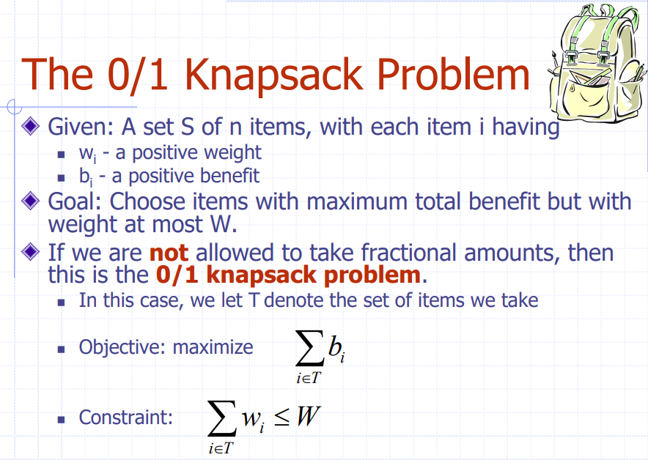

**And we are not allowed to take fractional amounts. Each item has a fixed weight and we cannot split it.**

# Give an example or given an instance of the problem, solve it

See iPad

# Explain the algorithm and how are choices made and why, any important properties involved in making such a choice

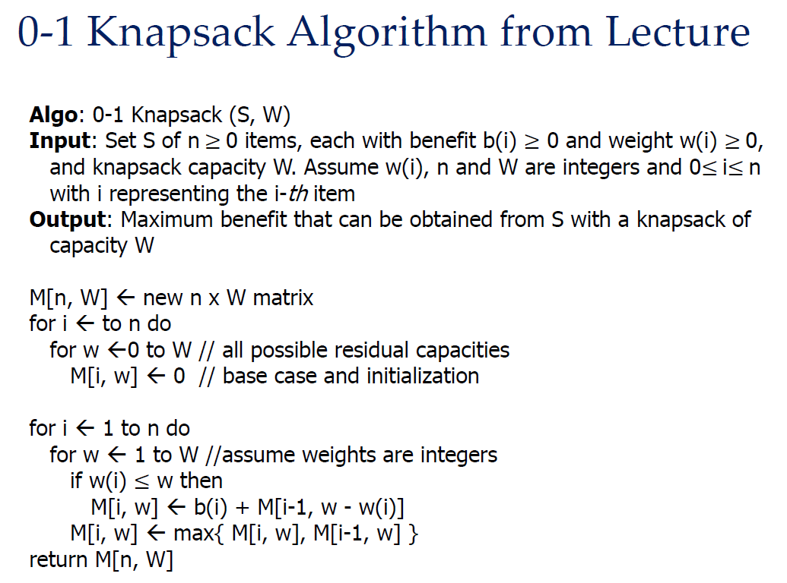

# Is it greedy or dynamic or some other type of algorithm, explain why?

Dynamic programming is better than Greedy Algorithm for the "0/1 Knapsack" problem.

**Reason:**

DP can construct simple subproblems, create subproblem optimality, and solve the trouble of subproblem overlap. In this context, DP can globally explore all possible choices and consequences, ensuring a globally optimal solution.

While Greedy Algorithm seems faster, it may not guarantee global optimality, because it always does locally optimal choices without considering the global impact.

通用回答，仅需替换红色部分问题名字.

# Compare/contrast the problems and algorithms

0/1: **We are not allowed to take fractional amounts from items. Each item has a fixed weight and we cannot split it.**

# Given a scenario would you use 0-1 Knapsack or Fractional Knapsack, or

# You give a scenario of when using 0-1 knapsack is appropriate and when Fractional is appropriate

见例题吧

# Given Fractional Knapsack algorithm prove it is correct, that it returns an optimal choice of weights of item to be included in the knapsack

见 Fraction Knapsack